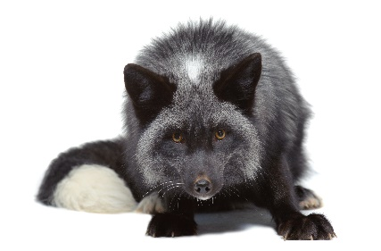
Returns Form
Customer Details  _________________________________  _________________________________  _________________________________  _________________________________  _________________________________ | Order Information  Invoice Number:__________________  Invoice Date: __________________  Order Number: __________________  Order Date: __________________

Refund/Exchange Instruction

Please complete the form below and return it with your item(s) using the pre-printed returns labels attached. To complete the form:

1) Enter the quantity you are returning against the relevant order line on the Returns Note.
2) On the same order line, circle a return reason letter code from those listed.
3)If you would prefer an exchange, please check available options on our website www.blackfoxes.co.uk and provide size/colour required item against the relevant order line.

Item code/  Description | Colour | Size | Quantity Returned | Return Code |  |  |  |  |  | Comments
 |  |  |  | A | B | C | D | E | F
 |  |  |  | A | B | C | D | E | F
 |  |  |  | A | B | C | D | E | F
 |  |  |  | A | B | C | D | E | F
 |  |  |  | A | B | C | D | E | F

Return Reasons Code:

A – Exchange required;
B – Wrong size;
C – Item is faulty;

D – Unwanted;
E – Product was not ordered;
F – Other _________________________________

Please return items in an unused, unworn and undamaged condition in its original packaging and all tags attached within 14 days of receipt. We do not provide refunds and free returns for unsuitable items. Items that have been used and become faulty after the purchase are not refundable. For the returned faulty items we will refund you the full cost including delivery charges, please send your postage receipt with item(s) back to us.

If you have asked for an exchange or replacement, we will inform you by email when the replacement item have been processed by our warehouse team. If, for any reason we are out of stock of an item, you will be offered a refund. If you have asked for a refund, we will refund your original payment method (i.e. Credit/Debit card or PayPal). Please allow up to 14 days for any refunds to appear in your account.
--------------------------------------------------------------------------------

Customer Returns
Black Foxes UK CIC
The Sty, 8a Market Square (Flat 2), Leighton Buzzard, Bedfordshire
LU7 1EY

